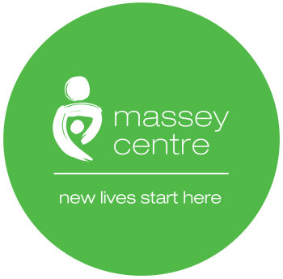

Massey Centre
Early Learning Centre COVID-19 Personal Protective Equipment

Name of Author: ELC Management Team
Ratified by: Senior Management Team
Document Version No: 01 2020
Latest Re-issue Date:
Review Date:
Date Approved by Senior Management Team: July 6, 2020

Amendment Record
Page number | Paragraph number | Change | Date of Change
Table of Contents

- Introduction 3
- Policy 3
- Procedures 3
- Acknowledgement and Agreement 4
- Appendices 5

- Introduction

  - The Massey Centre’s Early Learning Centre (ELC) is committed to developing an enhanced practice for Personal Protective Equipment for children, child care staff and essential visitors who enter the Early Learning Centre (ELC) Building.

- Policy

  - The Centre’s Personal Protective Equipment (PPE) policy is to protect employees from hazards that are present in the workplace. PPE is not a substitute for more effective control methods. PPE should be used based on the risk of exposure (e.g., type of activity) and the transmission dynamics of the pathogen (e.g., contact, droplet or aerosol). It is considered when all other means of hazard and risk control are not satisfactory or possible. It will be used with other controls unless there are no other means of control. The number of individuals accessing communal spaces should be limited to support physical distancing of at least 2 m. If individuals must congregate, they should be provided with clear instructions about when to use, how to put on and remove PPE and about hand washing or sanitization (with soap and water or with an alcohol-based solution of at least 70% alcohol) before putting on and after removing PPE.

- Procedures

  - Employees working in the ELC where physical/social distancing measures are challenging and difficult to maintain must wear a procedure/surgical /pleated mask. Employees must continue to self–monitor for COVID-19 symptoms and/participate in the screening process at one of the two screening stations at the beginning of every shift. If you feel you are displaying symptoms related to COVID-19, we ask you to notify your supervisor.

  - COVID-19 symptoms are defined below and may be mild. They include new onset of any one of the following:
- Fever
- Cough
- Difficulty breathing/shortness of breath

  - Staff will wear a surgical mask and eye protection (e.g., goggles, face shield, gowns):
- In the screening area, when screening or escorting children to child care area.
- When cleaning and disinfecting blood or bodily fluid spills if there is a risk of splashing or droplets.
- When caring for a sick child or a child showing symptoms of illness.

  - Staff will wear a mask (medical or non-medical) or face covering at other times when physical distancing cannot be maintained, including, but not limited to:
- Providing direct care (e.g. feeding, assisting a child with hand hygiene, diapering).
- Consoling an upset child.
- Assisting a child with dressing or changing clothes.

  - Gloves will be worn when it is anticipated that hands will come into contact with mucous membranes, broken skin, tissue, blood, bodily fluids, secretions, excretions, contaminated equipment or environmental surfaces.

  - Blankets will be used over clothing if holding or carrying infants or toddlers. Change the blankets or cloths between children.

  - It remains that staff must continue to practice social/physical distancing and proper hand hygiene throughout their shift and while performing their work duties. Massey Centre ELCs will provide personal protective equipment (PPE) for use by staff when necessary.
  - In addition to using the appropriate PPE, frequent hand washing or sanitization (with soap and water or with an alcohol-based solution of at least 70% alcohol), and respiratory hygiene should always be performed.

  - PPE should be discarded in an appropriate waste container after use, and hand washing or sanitization (with soap and water or with an alcohol-based solution of at least 70% alcohol) should be performed before putting on and after taking off PPE.

  - All client-facing service staff must be trained in performing hand hygiene and how to put on and remove PPE to avoid self-contamination.

- Acknowledgment and Agreement

I, , acknowledge that I have read and understand Personal Protection Equipment Policy and Procedures of Massey Centre. I agree to adhere to this policy in whole. I understand that if I violate the rules set forth in this policy, I may face disciplinary actions, up to and including termination of employment.

Full Name
Please Print
Signature
Date
MM/DD/YYYY
Appendices

Rational use of Personal Protective Equipment for Coronavirus disease (COVID 19) adapted for the Centre from World Health Organization
Proper Use of Mask, and its disposal
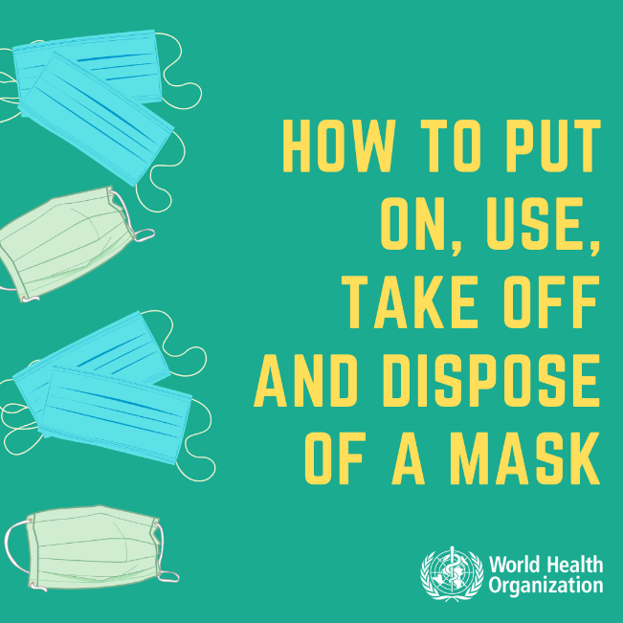 | 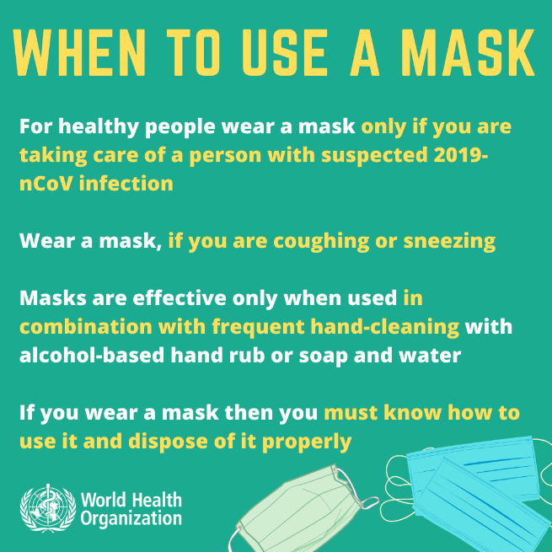
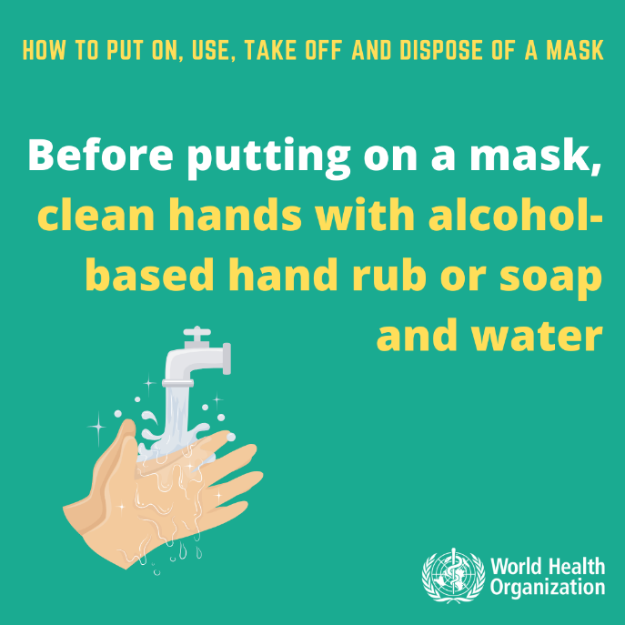 | 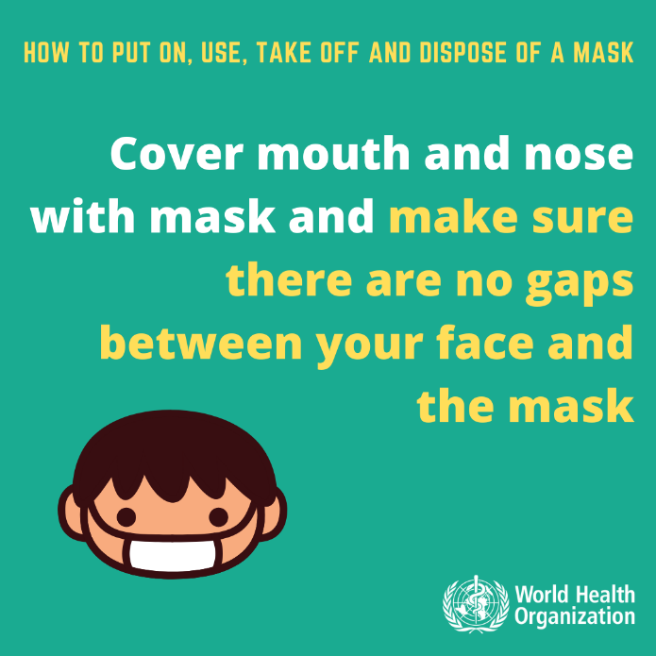

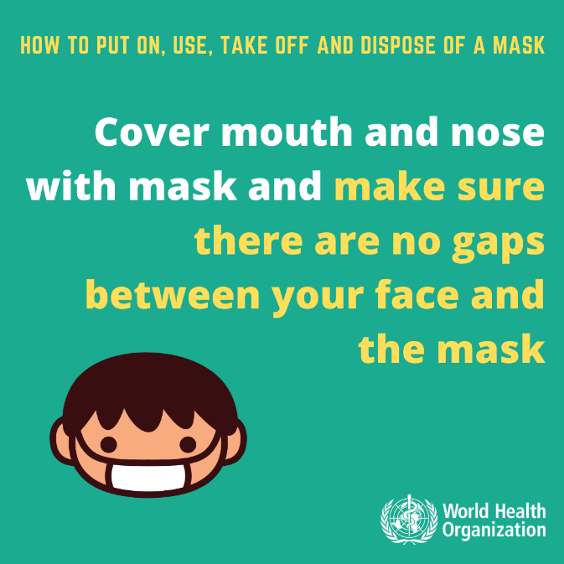 |  | 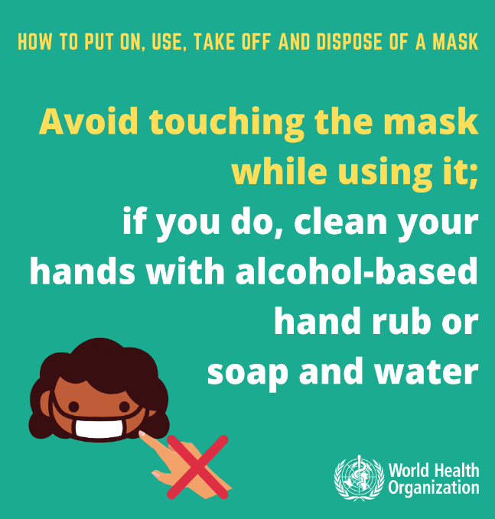
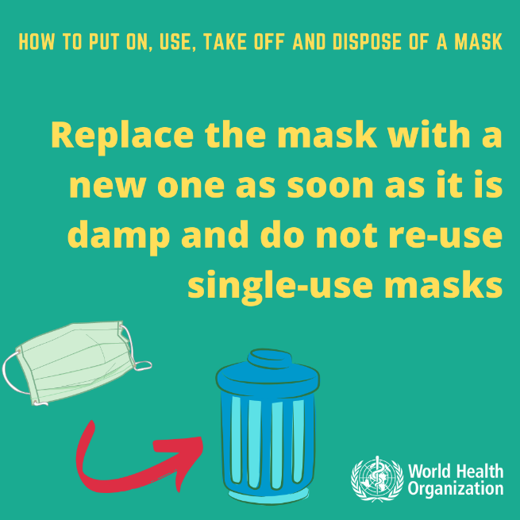 |  | 